**Aditya Mhatre**

[**17033712@brookes.ac.uk**](mailto:17033712@brookes.ac.uk)

Post rig software tutorial

Table of Contents

Introduction 2

1. Starting the Software 2

1.1. Download and Extract 2

1.2. Installation 3

1.3. Uninstalling 4

2. Creating a New Project 5

3. Design Tab 6

4. Simulation Setup: 7

4.1. Initial Condition 8

4.2. Harmonic Input 9

4.3. Combined Input 10

5. Run 12

# List of Figures

Figure 1: Extract Folder 2

Figure 2: PostRig Application Installer 3

Figure 3: Start Up Menu 3

Figure 4: Uninstall 4

Figure 5: Blank Project 5

Figure 6: Design Tab 6

Figure 7: Initial Condition Definition 8

Figure 8: Harmonic Force Definition 9

Figure 9: Combined Input Definition 10

Figure 10: Simulation Setup 11

Figure 11: Results Display 13

Figure 12: Results Tab 13

# Introduction

The Post Rig is a software which help the user study how a One Degree of Freedom Spring Mass Damper System responds to different input conditions. This document is a step by step guide for any new user to start using the software.

# Starting the Software

In order to start the software first you need you install it. This topic explains how to install the software. The first step in doing so is to download the PostRig Zip Folder from the link in the email.

## Download and Extract

Once downloaded, the zip folder will can be accessed in the Download folder in you Computer. The PostRig folder needs to be extracted which can be done by clicking the Extract All button on the top which will open and Extraction Wizard asking for the location as seen in Figure 1. Extract the folder to the desired location and click Extract.

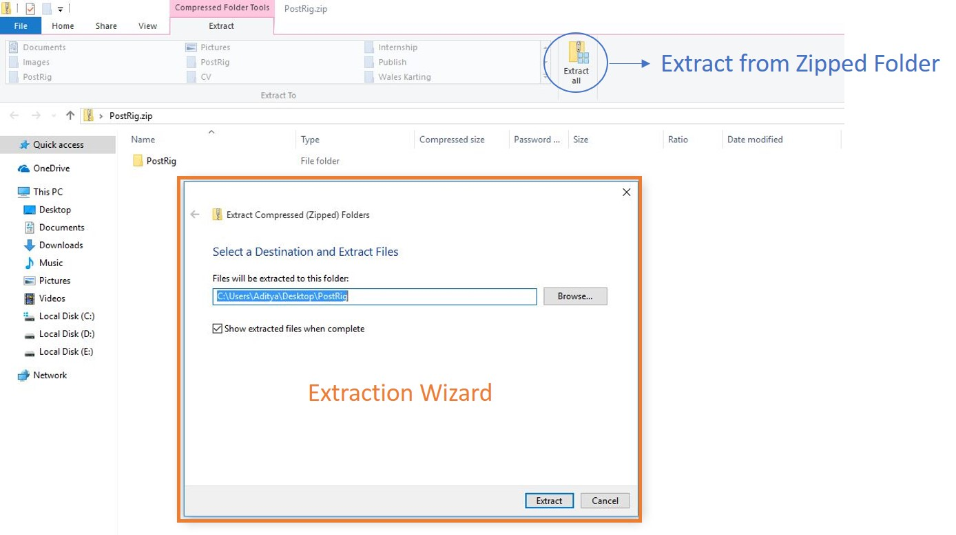

Figure 1: Extract Folder

## Installation

Once Extracted, please go the location where the folder is extracted and open it. This folder will contain the Setup File. Run the setup.exe, which will open the Application Installer (Figure 2). Click on install and the software will open once the download is complete. The software can also be found in the Start Up Menu (Figure 3) and also on the desktop for easy access. This will open a blank project as shown in Figure 5.

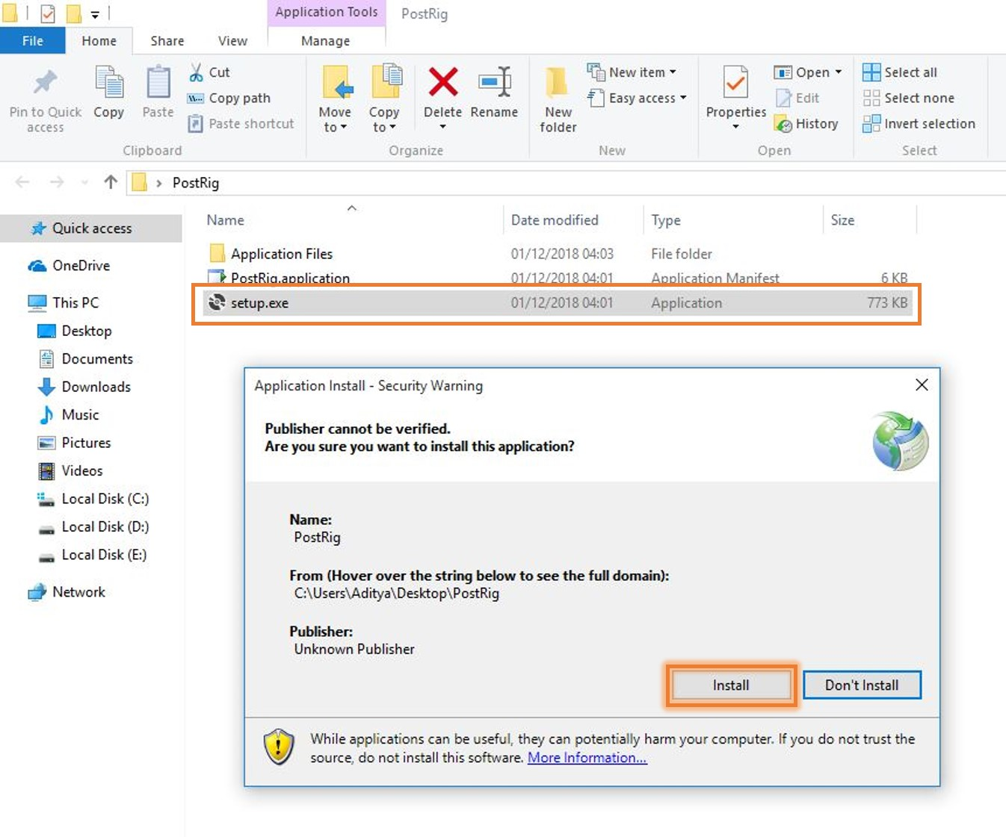

Figure 2: PostRig Application Installer

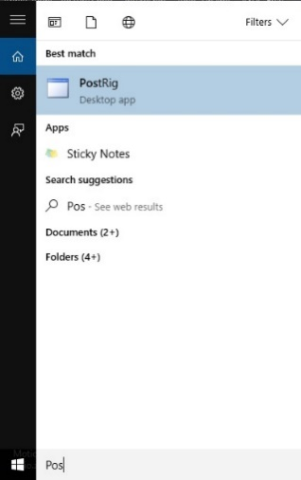

Figure 3: Start Up Menu

## Uninstalling

The software can be uninstalled from the Apps & Features in the setting of your computer. Uninstall it from there by searching for Post Rig and clicking uninstall (Figure 4.)

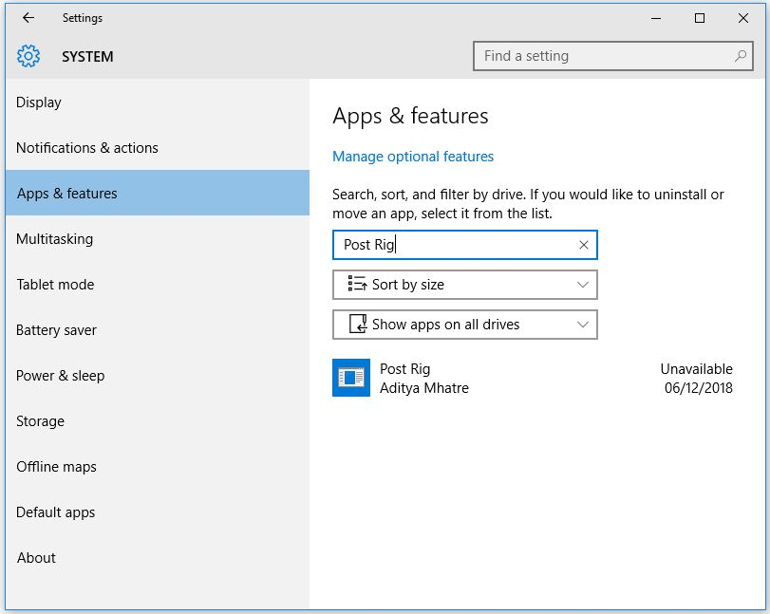

Figure 4: Uninstall

# Software Start Up

Once the software has been installed, an icon is created on the desktop. The software will open as soon as the installation is complete. The software can also be opened by the icon created on the desktop or in the start-up menu. Once the software is opened it will display the home page as shown in Figure 5.

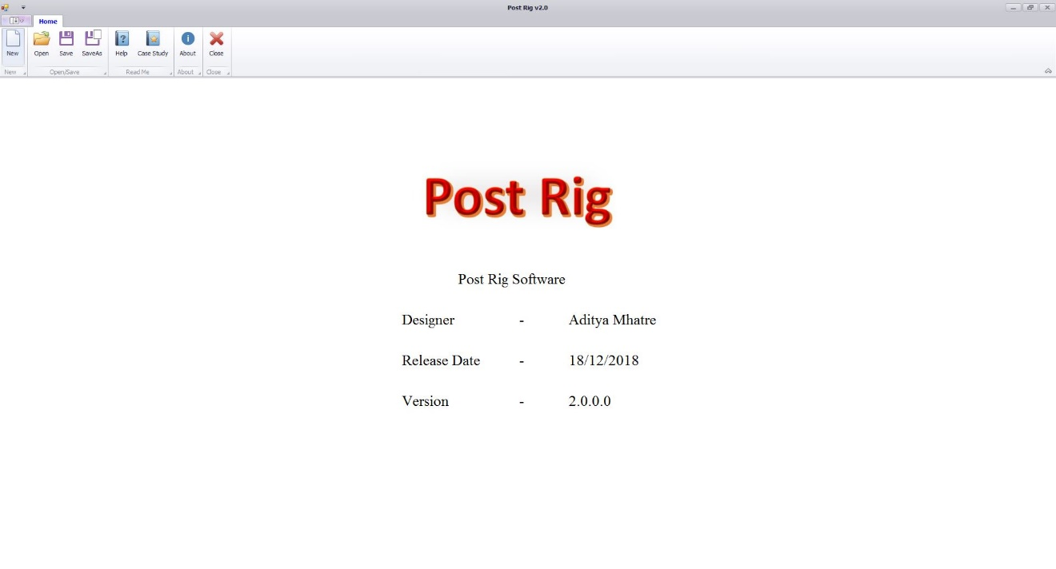

Figure 5: Home Page

Once the software starts up, only the Home Page is visible. The options available in the home page are shown in Figure 6. This contain options such New, Open, Save, Save As, Help, Case Study, About and Close. As brief descriptions and functionalities of the above options are mentioned below.

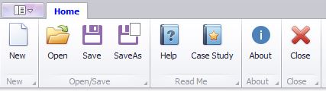

Figure 6: Home Ribbon Options

## New

The New button is used to start a new project. On clicking this option, a new project is started and the Design, Simulation Setup and Results tabs are visible. These tabs as are only visible when a new project or an existing project is started.

## Open

The Open buttons is used to open an existing project. This software will only open only Post Rig files (.postrig). Once an existing project is opened the software will switch to the Design page.

## Save

The Save

# Design Tab

The Design Tab provides templates for a Road Car, Touring Car or a Single Seater as shown in Figure 6. By selecting either of them, the corner weights, spring stiffness and damping coefficients are filled in automatically in their respective fields in the Property Tree. The corner weight is calculated by assuming a Front-Rear and Right-Left weight distribution of 50-50. The values for these templates are mentioned in Table 1. The template values can be overridden by simply changing the figures in the value column to the desired value.

|  |  |  |  |  |
| --- | --- | --- | --- | --- |
| **Template** | **Total Weight (kg)** | **Corner Weight (kg)** | **Spring Stiffness (N/m)** | **Damping Coefficient (N/(m/s))** |
| Road Car | 1600 | 400 | 80000 | 4000 |
| Touring Car | 1000 | 250 | 120000 | 8000 |
| Single Seater | 700 | 175 | 150000 | 8500 |

Table 1: Vehicle Template

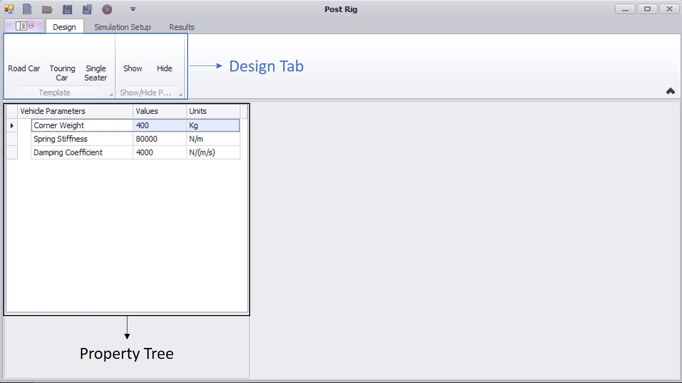

Figure 7: Design Tab

The Show/Hide options in the Design Tab will Show and Hide the property tree if the user wishes to do so.

**Note: If changes are made to the Vehicle Parameters and if any template is clicked, the values will be reset to corresponding values in Table 1.**

# Simulation Setup:

An Important note to remember before moving any further is that, **motion that causes the spring and damper to compress are positive in magnitude and extension of spring and damper are negative in magnitude.**

Once the design parameters have been entered, the next step is setting up the simulation. In the Simulation Setup Tab, the Input Setup Group there are three check boxes, i.e. Initial Conditions, Harmonic Input and Combined Input. The simulation results are time based, therefore when any of the checkboxes in the Input Setup are selected time data is accessible to be changed if needed. By default, the time data for the simulation is mentioned in Table 2.

|  |  |  |
| --- | --- | --- |
| **Time Data** | **Values** | **Units** |
| Start Time | 0 | Seconds |
| Time Steps | 0.001 | Seconds |
| End Time | 10 | Seconds |

Table 2: Time Data

The details explaining Initial Conditions and Harmonic Input are mentioned in the sections below.

## Initial Condition

The Initial Conditions Input Setup calculates the response of the system to an initial displacement, an initial velocity or both imparted on the body.

Assume that the body is displaced by an amount . As shown in Figure 7, the Initial Condition Simulation setup calculates the response of the system when it is displaced by an amount from its equilibrium position. Similarly, Initial Velocity is the velocity imparted on the body to impose a motion on the system.

When this input setup is checked the Simulation Setup Tree displays Time Data and Initial Condition Data. By default, Initial Condition Data are set to the values given in Table 3.

|  |  |  |
| --- | --- | --- |
| **Initial Condition Data** | **Values** | **Units** |
| Initial Displacement | 0.005 | m |
| Initial Velocity | 0 | m/s |

Table 3: Initial Condition Data

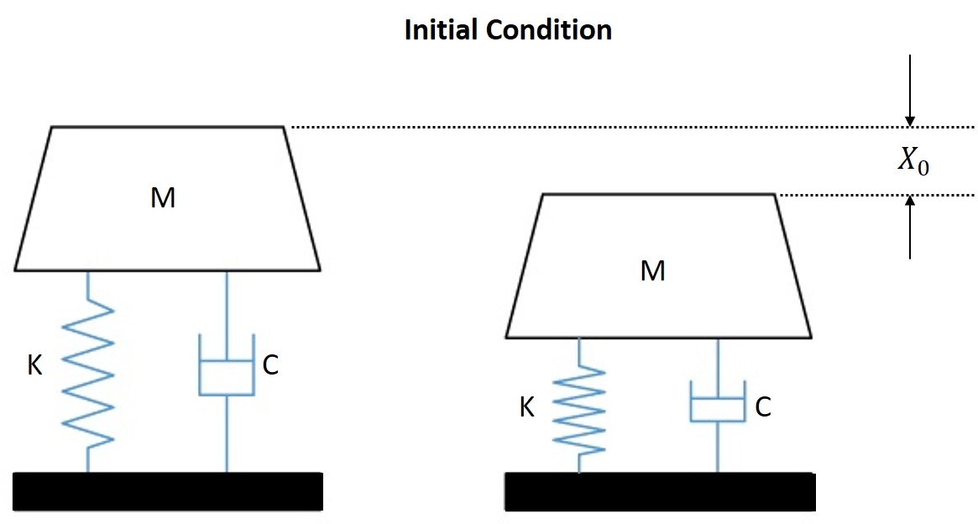

Figure 8: Initial Condition Definition

Here M, K, C, and are Corner Weight, Spring Stiffness, Damping Coefficient, Initial Displacement and Initial Velocity.

## Harmonic Input

The Harmonic Input Setup calculates the response of the system to a Harmonic Force Input imposed on the body.

A Harmonic Force is imposed on the body and the response of the system is calculated using this simulation setup. The Magnitude of the Force () and Frequency of Harmonic Oscillation () must be entered. The software will calculate the Harmonic Force Input which is imposed on the body using the equation as shown in Figure 8.

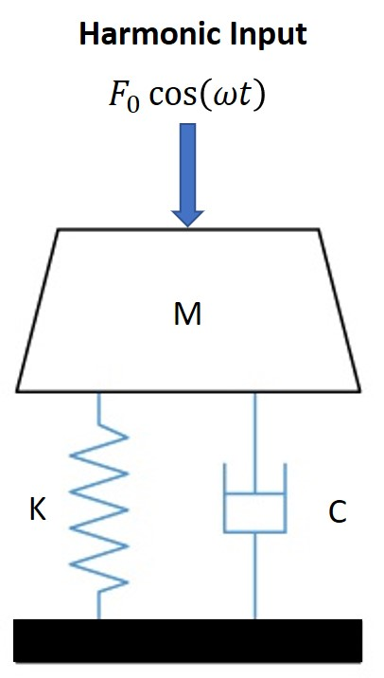

Figure 9: Harmonic Force Definition

To setup the simulation, the force amplitude and the harmonic oscillation frequency. By default, the Harmonic Input Data are set to the values mentioned in Table 4.

|  |  |  |
| --- | --- | --- |
| **Harmonic Input Data** | **Values** | **Units** |
| Oscillation Frequency | 1 | Hz |
| Force Magnitude | 10 | N |

Table 4: Harmonic Input Data

## Combined Input

The Combined Input Setup calculates the response of the system to a combination of both Initial Condition and Harmonic Input. When this setup is selected it gives access to both Initial Condition Data and Harmonic Input data set to the default values mentioned in Table 3 and Table 4.

Combined Input calculates the response of the system for a combination of Initial Condition and Harmonic Force (Figure 9). This means the body is initially displaced by the Initial Displacement () and released, followed by a constant Harmonic Input on the body and the response for this combined input is calculated.

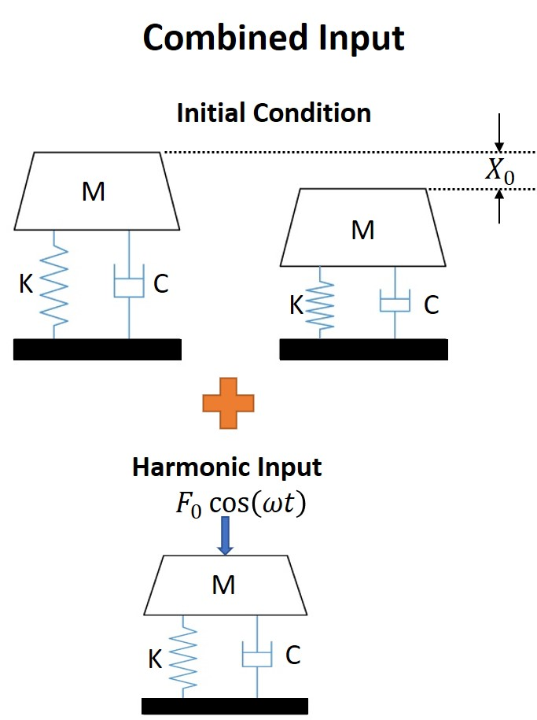

Figure 10: Combined Input Definition

Once the simulation is setup, it is ready to Run. Click the Run Button, once the calculations are complete a message box will appear stating Run Complete. Click Ok and move on the Results tab to view the results.

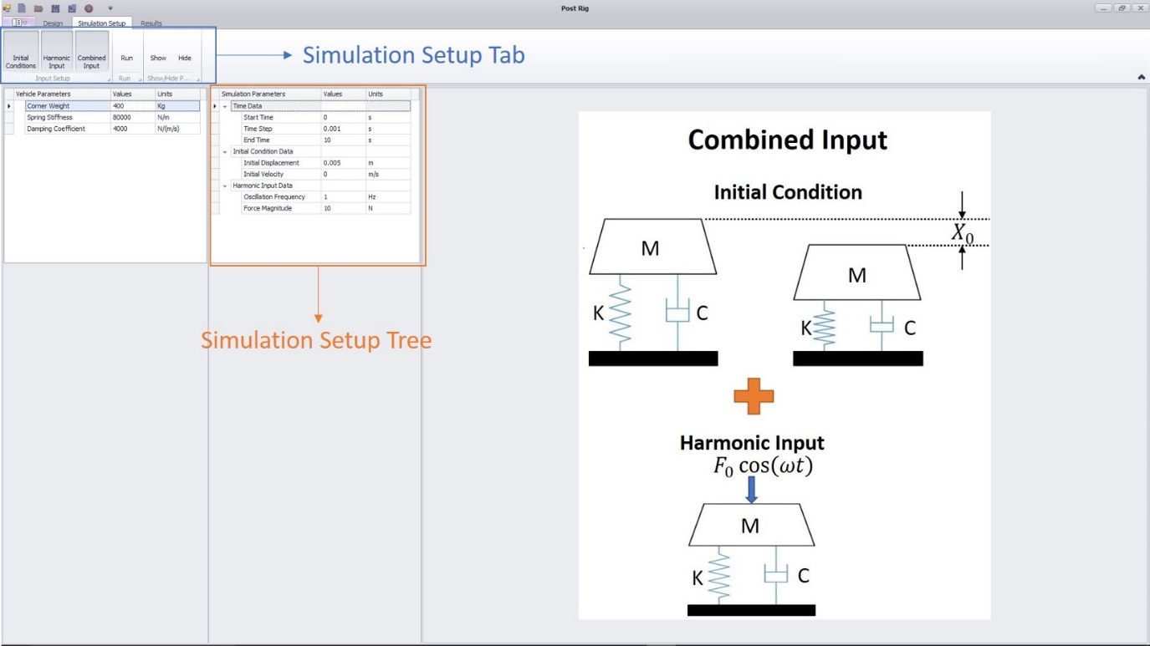

Figure 11: Simulation Setup

The Show/Hide options in the Simulation Setup Tab will Show and Hide the Simulation Setup Tree and Input Definition Image, if the user wishes to do so.

**Note: If you need to run a new Simulation, you need to update the necessary simulation data and click the respective Input Setup again though it is checked and Run again.**

# Run

Before running the simulation, the Results Tab only has the option of displaying System Characteristics, but will only display the System Characteristics Tree with no results. All the results will be displayed once the simulation has been run. Once the simulation is run, the Simulation Setup Tree is hidden and Responses, Forces and Acceleration can be plotted.

|  |  |
| --- | --- |
| **System Characteristics** | **Units** |
| Natural Frequency | Hz |
| Critical Damping | N/(m/s) |
| Damping Ratio | - |
| Frequency Ratio | - |
| **Output Plots** | **Units** |
| Response to Initial Condition (Time vs Displacement) | m |
| Response to Harmonic Input (Time vs Displacement) | m |
| Combined Response (Time vs Displacement) | m |
| Spring Force | N |
| Damper Force | N |
| Body Force | N |
| Body Acceleration | m/s2 |

Table 5: Output Results

All the output results that are displayed in the software are mentioned in Table 5. Results Tab displays all the results that can be plotted which are displayed in the Plot Area. The System Characteristics are displayed in the System Characteristics Tree which can be hidden using the hide option in the Results Tab, which can be seen in Figure 11.

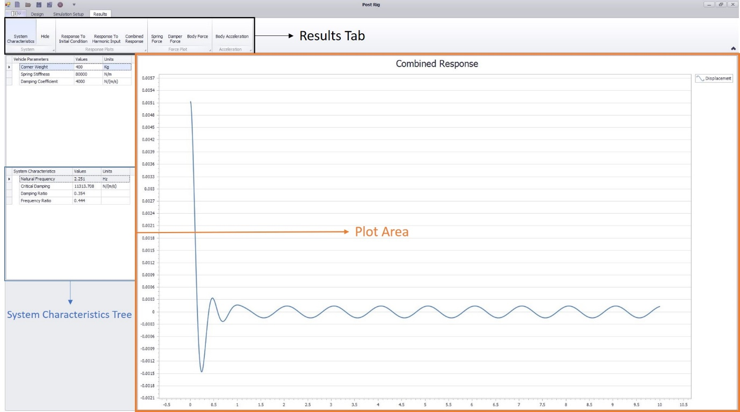

Figure 12: Results Display

Depending on the Input Setup selected the Results tab will give access to the corresponding response plots. Figure 12 shows the different response plot options for the respective Input Setup. All the results graphs are displayed.

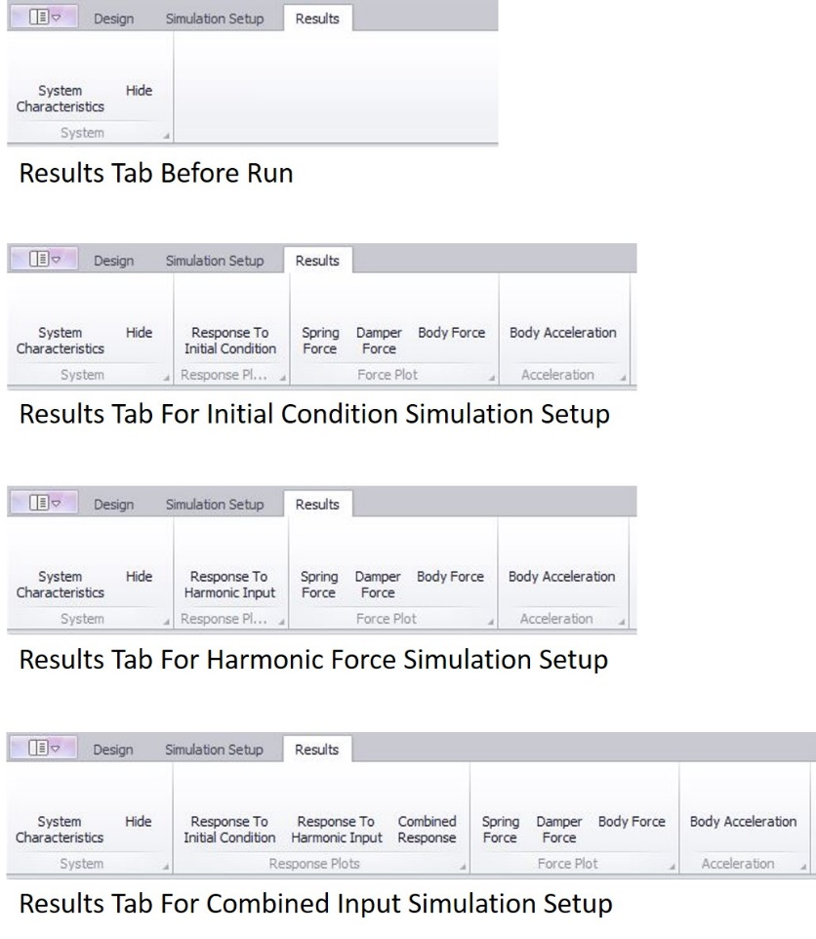

Figure 13: Results Tab